**Week 3 Discussion Forum 2 – Testing Techniques, Types, and Levels**

Vicki Kelm

The University of Arizona Global Campus

CST 499: Capstone for Computer Software Technology

Dr. Amjad Alkilani

January 11, 2024

**Concept Map**

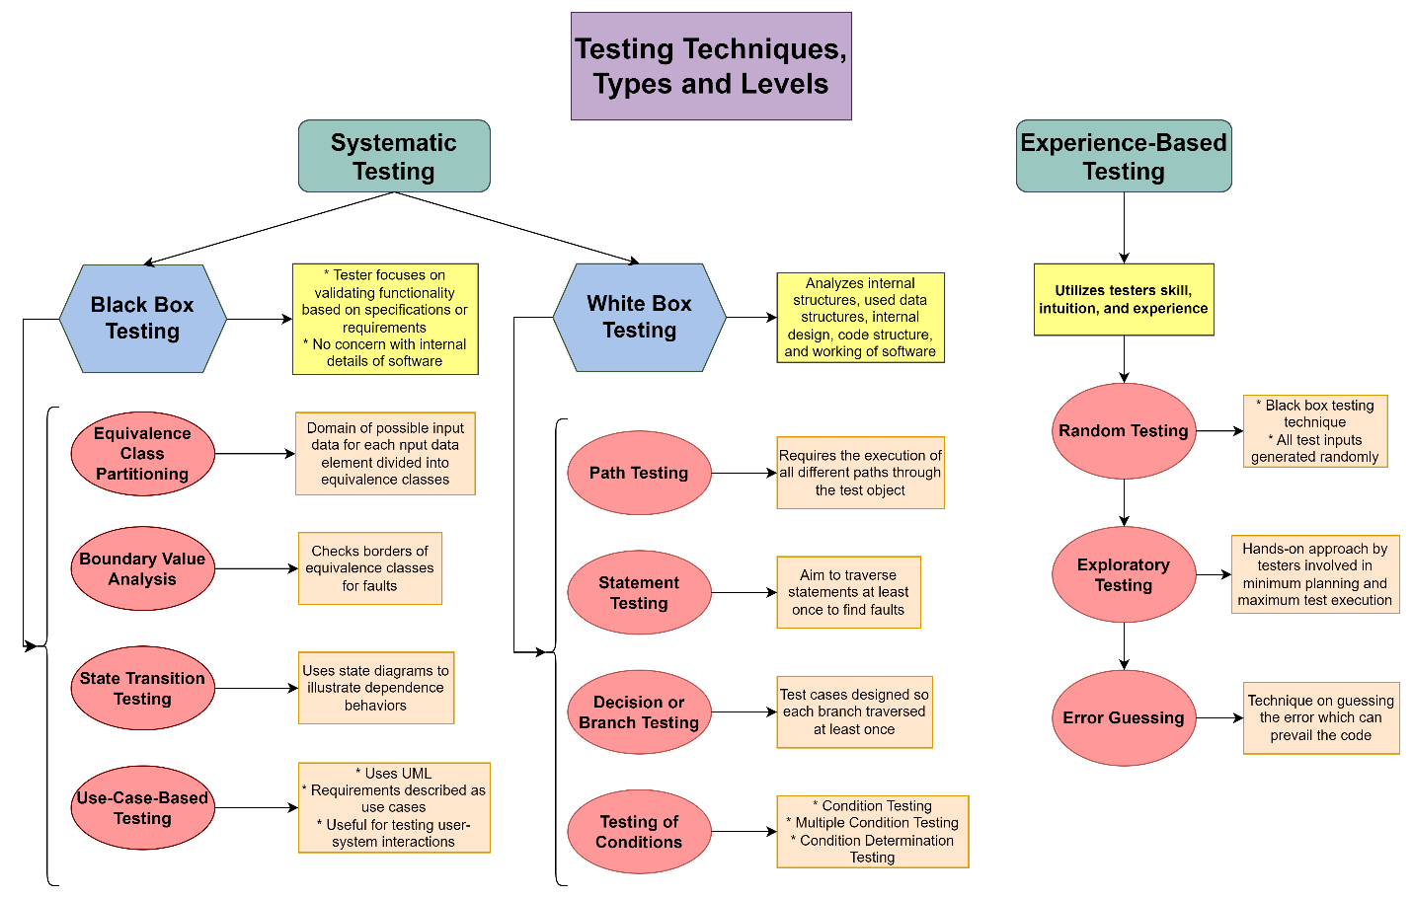

**Week 3 Discussion Forum 2 – Testing Techniques, Types, and Levels**

The main goal of software development is to produce high-quality software that is well defined to meet specifications and is fit to use. In order to achieve this level of quality software there must be testing performed. This paper will propose an answer to the question: When is the right time to stop testing?, discuss the various testing techniques and levels, and explain how coverage data supports a determination of when to stop testing.

**When is the right time to stop testing?**

The determination of when to stop testing is not very definitive due to the criteria and constraints of a project. However, there are some common factors that can help to determine when to stop.

* Release or testing deadlines have been met or the budget has been depleted.
* Test cases have been executed with a certain degree of passing and test coverage has been achieved.
* Code coverage, functionality coverage, and requirements coverage have reached a specified point.
* Bug rate falls below a certain level and there are not known critical bugs.
* Management decides to stop testing due to business or strategic reasons.

“A simple answer is to stop testing when all the planned test cases are executed and all the problems found are fixed” (Tsui, Karam, & Bernal, sect. 10.4).

**Discuss the various testing techniques and levels**

There are three main levels for testing: Unit Testing, Functional Testing, and Integration and System Testing. Unit testing involves the testing the functionality of individual units, like a single procedure or method. Functional testing involves determining whether individual units work as a functional unit when put together. Integration and system testing involves the testing of the integrated functionality of the complete system (Tsui, Karam, & Bernal, sect. 10.2.1).

There are three main categories of testing techniques that can be utilized: Black-Box, White-Box, and Experienced-Based Testing.

“Black-Box Testing is a type of software testing in which the tester is not concerned with the internal knowledge or implementation details of the software, but rather focuses on validating the functionality based on the provided specifications or requirements” (Black box Testing, July 2023). Some techniques include the following:

* Equivalence Class Partitioning
* Boundary Value Analysis
* State Transition Testing
* Use-Case-Based Testing

“White Box Testing techniques analyze the internal structures, the used data structures, internal design, code structure, and the working of the software rather than just the functionality as compared to black box testing” (White box Testing, May 2023). This testing method is used to test the software’s internal logic, flow, and structure. These techniques include the following:

* Path Testing
* Statement Testing
* Decision Testing or Branch Testing
* Testing of Conditions

“The Experience-Based Testing technique is utilizing tester’s skill, intuition, and experience with similar applications or technologies” (Tutorialshut). Reasons for using this technique is when there is non-availability of requirements and specifications, limited knowledge of software product, time restrictions, and that this testing finds more defects. The different types of techniques include the following:

* Random Testing
* Exploratory Testing
* Error Guessing

**Explain how coverage data supports a determination of when to stop testing**

Coverage data can be used to help determine when to stop testing by providing a picture of both functional and non-functional requirements have been tested and the level of testing completed on each. A test coverage of 100% shows that the requirements have been tested, and therefore safe to end testing.

A high-quality software product is achieved using ways to detect and to later correct errors. Testing techniques are used to take a project from inception to completion after it has been validated. This paper proposed an answer to the question: When is the right time to stop testing?, discussed the various testing techniques and levels, and explained how coverage data supports a determination of when to stop testing.

**References**

GeeksforGeeks. (2023, July 19). *Software Engineering | Black box testing*. <https://www.geeksforgeeks.org/software-engineering-black-box-testing/>

GeeksforGeeks. (2023, May 09). *Software Engineering | White-box Testing*. <https://www.geeksforgeeks.org/software-engineering-white-box-testing/>

Spillner, A., Linz, T., & Schaefer, H. (2014). *Software Testing Foundations: A Study Guide for the Certified Tester Exam (4th ed.)*. <https://ashford.redshelf.com/app/ecom/shelf/course-section/6094369>

Tsui, F., Karam, O., & Bernal, B. (2018). [Essentials of software engineering](https://uagc.instructure.com/courses/126521/modules/items/6439323)(4th ed.). Jones & Bartlett Learning.

TutorialsHut. (n.d.). *What is Experienced Based Testing Techniques*? <https://tutorialshut.com/experienced-based-testing-techniques/>